


Columbia High School - 301 S. Happy Valley Rd. Nampa, ID 83686
(208) 498-0571 x 6513  www.columbiawrestling.net
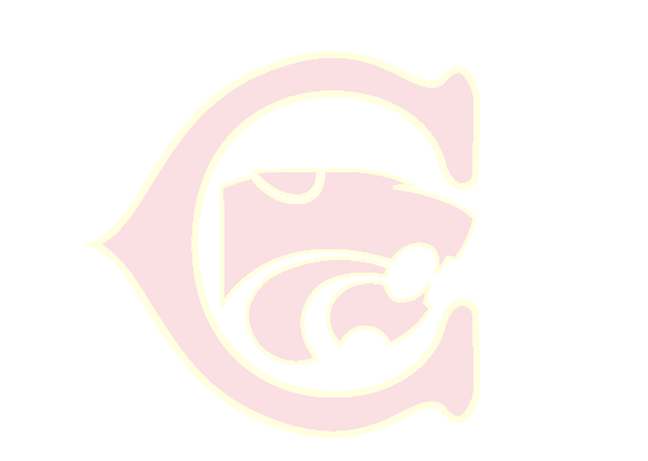
Todd Cady-
Head Coach

Conference Champions
2008
2009
2010
2011
2013
2016
2017
2018
2019

District Champions
2008
2009
2010
2011
2013
2016
2017

State Tournament Finishes
2007 – 10th
2008 – 2nd
2009 – 1st
2010 – 1st
2011 – 1st
2012 – 2nd
2013 – 1st
2014 – 2nd
2015 – 7th
2016 – 2nd
2017 – 1st
2018 – 4th
2019 – 2nd
2020 – 2nd
Columbia Wrestling Signature Sponsorship “GOLD Sponsor”
2020-2021

Columbia Wrestling of the Nampa School District in Nampa Idaho, a premiere wrestling program in the Pacific Northwest is seeking Signature Sponsors for the upcoming wrestling season.

Signature Sponsors are sponsorships at the level of $500 for the season. Columbia Wrestling is 100% self-funded. The championship program runs at a cost of approximately $25,000 each season to operate, to cover these costs the program exerts a great deal of energy on fundraising. Signature Sponsorships allow us to cut back on the number of smaller fundraisers that the program must run throughout the season, thus allowing for more of an emphasis on developing winning techniques for on the mat.

A wrestling season at Columbia runs at a large cost of operation based on its focus of developing Champions On and Off of the Mat. A philosophy that is geared towards building our athletes into young adults that will build, through wrestling, skills to be productive members of our community, young adults that are ready for life’s challenges and for them to be prepared to be great parents, employees and citizens. The $25,000 season expense can be broken down into the following categories:
- Tournament Entry Fees: $3,200
- Tournament Travel and Lodging: $12,000
- Wrestler Uniform “Scholarships”: $5,000
- Equipment: $1,200
- Pre/Post Season National Tournaments: $4,000

Signature Sponsorships for Columbia Wrestling will include the following for the sponsoring entity:
- Tax Write Off
- Sponsorship of Columbia group of weight classes, announced at each home match
- 2 full screen TV ads (64” TV) for all home matches during the season at CHS gymnasium
- Logo displayed at the Rollie Lane Wrestling Tournament hosted by CHS and held at the Ford Idaho Center
- Sponsorship of a mat at the Rollie Lane Tournament, Columbia JV Tournament and Jaybird Invitational (Idaho’s first ever all-girls high school sanctioned wrestling tournament)
- Logo displayed on the Columbia Wrestling Web Page
- Logo presented on all home match programs
- Logo included in the Rollie Lane program
- Free winter sports passes for up to four, good for wrestling and both girls and boys basketball events
- Free entrance for up to four to all Columbia hosted wrestling tournaments

Thank you for your consideration in supporting the Columbia Wrestling Program and its attempts to build young adults who will be contributing members to our community.

Coach Todd Cady

